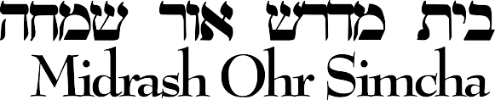


Rabbi Akiva Engel
www.ohrsimcha.net

September 5785-5786 / 2025-2026

Dear Members and Friends,

As the Yomim Noraim approach and we prepare to begin a new year, we take a moment to reflect with gratitude on the incredible growth and accomplishments of our beloved Bais Medrash Ohr Simcha. For over 30 years, our shul has been a warm and welcoming makom Torah, dedicated to Torah, mussar, and chesed.

With tremendous siyata d’Shmaya, our kehillah continues to flourish. We are privileged to welcome many new families and members, and Baruch Hashem we have been able to expand our learning opportunities. Today our shul offers a Morning Kollel, Night Kollel, and vibrant Shabbos learning programs—allowing Torah to be accessible to everyone in our community.

To continue maintaining and growing these vital programs, we turn to you for support. Membership fees are a cornerstone of our ability to meet the shul’s ongoing needs. As you are surely aware, expenses across the board have risen significantly this past year. To keep up with these rising costs, our membership rates will be increasing slightly for the coming year. We kindly ask that each household participate to the best of their ability—and, if possible, consider giving above the base fee—to help sustain and strengthen Torah in our community.

Monthly payment options are available, and every contribution makes a meaningful difference. We deeply appreciate your partnership and generosity.

May HaKadosh Baruch Hu accept our tefillos with rachamim and grant us a year filled with health, simcha, and bracha.

With heartfelt wishes for a ksiva v’chasima tova, a gut gebentsht yohr, and a beautiful Yom Tov,

Bais Medrash Ohr Simcha

1 2 4 3 0 O X N A R D S T R E E T • N O R T H H O L L Y W O O D • C A • 9 1 6 0 6

